Portland in the Streets: Community Grant Application
Submitted by: Hayden Island Neighborhood Association (Hi-Noon)


Hayden Island Virtual Tour

A “virtual walking tour” around Hayden Island
using QR codes and Bluetooth Beacons

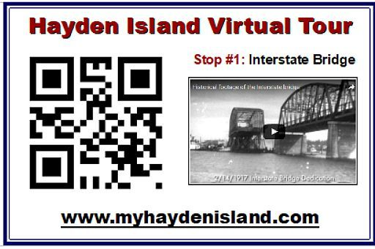
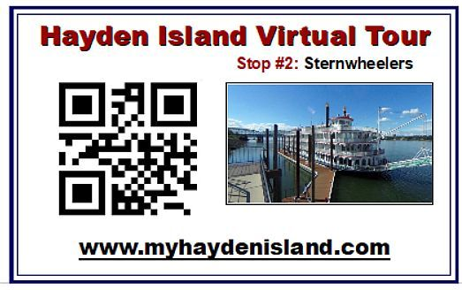
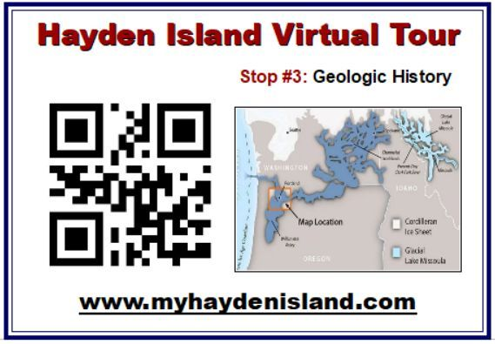
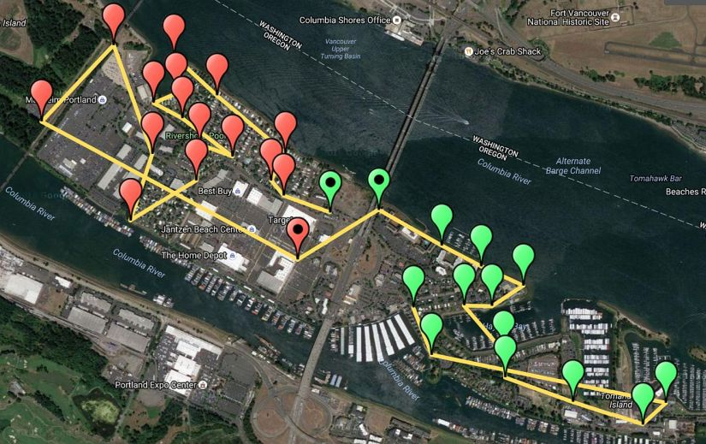

_________________________________

1. APPLICANT INFORMATION
Project Title: Hayden Island Virtual Tour
Requested Funding Amount: $4,450
Hosting Organization: Hayden Island Neighborhood Association (HiNoon)
Is this a Non-Profit? Yes, 501(c)3, Tax ID#: 173584-90
Mailing Address: 12451 North Westshore Dr, Hayden Is. 97217
Project Coordinator: Sam Churchill, Ph: 503.740.9209, Email: schurchill@gmail.com
Secondary Contact: Jeff Geisler, Ph: 503.936 2425, Email: jeffgeisler@msn.com

2. FISCAL SPONSOR [if applicable]
Name: Hayden Island Neighborhood Association (HiNoon)
501(c)3 Tax ID#: 173584-90
Fiscal Sponsor Mailing Address: 2209 N. Schofield St, Portland, OR 97217
Contact: Jeff Geisler, Chairman, HiNoon
Phone: 503.936.2425
Email: jeffgeisler@msn.com

3. PROJECT NARRATIVE:
Overview: A “virtual walking tour” is created around Hayden Island. It uses QR codes, which can be created at little or no cost, to guide visitors around the island. Both (passive) QR codes and (active) Bluetooth beacons are used to send a url to a phone without typing. Clicking on the QR code scan or the Beacon notification automatically directs the user's phone to the appropriate webpage, hosted on the neighborhood association's website.
The walking tour highlights some of the most interesting aspects of the island, using the land, the people, and the water as themes. Visitors walking past each sign can be automatically redirected to the appropriate website for each of 25 locations around the island.
The QR coded signs are placed along the sidewalk mostly on Hayden Island Drive (West of the I-5 Bridge) and Tomahawk Drive (East of the I-5 Bridge). The 3"x5", laminated signage is placed on a lamp post, about 5 ft above the sidewalk.
A Bluetooth beacon would supplement the QR code signage. Beacons would be attached magnetically on the same lamp post, high above the QR signs. The Bluetooth beacon is placed inside a small (5" x 2.2") weatherproof, magnetic case, and would be nearly invisible, running continuously 1-2 years on the enclosed battery. Battery changing takes only a few minutes.
The beacons simply “broadcast” a url about 100 feet, using Bluetooth. NO remote internet connection is necessary. The user’s phone makes the broadband connection to the webpage.
Project Title: Hayden Island Virtual Tour
Project Location: About 25 different locations on Hayden Island
Describe this project: Creative Community Infrastructure and Innovative Community Engagement
Describe your organization: Hi-Noon is the official ONI representative for Hayden Island. The Virtual Tour is hosted and managed by HiNoon at their website.

PROJECT PROPOSAL
Describe the specific project and issues being addressed:
Hayden Island is a destination spot and will become more so in the near future. Many visitors stay at one of the three large hotels while attending events at the Expo Center, Delta Park or sternwheeler rides up and down the Columbia River. Others come to boat or fish. Island visitors will increase when the Vancouver Waterfront development opens in 2018. This “virtual tour” unites visitors and residents in a shared appreciation of place.
This “virtual tour” guides people through the history, nature and people that created the island. Some 25 unique locations are matched to 25 unique web pages by QR codes which eliminate typing in a URL. QR codes must be scanned by the phone and require a free scanner app.
Active Bluetooth beacons eliminate the need to scan the barcode. Beacons constantly send a URL to all phones or tablets within 100 feet. Users click on the Bluetooth notification to retrieve the appropriate webpage. That makes linking to content nearly effortless. No scanning or downloaded apps are required. Just turn on your phone's Bluetooth to receive the messages. The RuuviTag, a $25 Bluetooth 5 beacon, would be inserted in weather-proof magnetic containers, attached high on lamposts around the island's main roads.
We will also laminate a $1 battery-less NFC tag to the back of each sign. Android phones need only touch the sign to go to the website. The phone's NFC antenna powers the tag with the appropriate url. But Apple won't support NFC until IOS 11, so we'll underplay this feature.
What goals do you have for this project? How will you measure project success?

We want to celebrate Hayden Island’s history, people, nature and businesses. This proposal highlights some of the most interesting aspects of the island, using the land, the people, and the water as themes. The goal is a deeper appreciation of place for both the island’s residents and visitors. Success can be measured directly by usage statistics on the neighborhood association’s website.
How will the community (beyond your organization) benefit from this project?
This proposal is designed to enhance a sense of community for both residents and visitors. Next year, Vancouver’s Waterfront will open with hundreds of new hotel rooms, new office space and new residential condominiums. It will inevitably bring additional visitors to Hayden Island and increase traffic and congestion. By focusing on the land, water, people and history of the island, we will provide leadership for innovative business models, while enriching the experience for everyone.
What role does equity play in your project, leadership development, and/or its benefit to the community?
Celebrating diversity is one of the main goals of this project. The Virtual Tour will showcase several people each year, living and dead, who have made a difference in the community. Residents can vote (or nominate) a candidate, with the winner receiving a $250 honorarium and QR Code/signage recognition. The web pages will be multi-lingual and multi-cultural, supporting an inclusive big tent, welcoming everyone and encouraging engagement.
4. PROJECT IMPLEMENTATION + MAINTENANCE
TIMELINE: Please provide a proposed timeline for project implementation. Include key milestones, anticipated completion date, and reporting , (as outlined in Grantee Expectations):
Oct-Dec, 2017: Upon notification of award, a committee of community members will research possible storylines and build out the 25 dedicated web pages featured on the Tour.
Jan-Feb, 2018: Laminated QR code signs are created and placed around the island for an initial (phase-one) rollout. Posters explain the use and goals of the Virtual Tour.
Feb 14, 2018: Local media is invited to an initial launch event on Feb 14th (Oregon’s birthday), to celebrate “I (Heart) Hayden Island”. Press release kits with QR code signage are available for the press and interested parties.
Feb-May, 2018: Bluetooth 5.0 Beacons are ordered and tested in the field to enable most Android and iPhones to use the Virtual Tour without the necessity of installing a QR code reader app. Refinement of the multi-media library will include embedded narration, royalty-free music, videos, and multi-lingual support. Two long-range Beacons will reach across the Columbia River to the Vancouver Waterfront, engaging the public through a Facebook page.
June 2018: A block party celebrates the full completion of initial Virtual Tour in June. It includes games, like a ping-pong table with I-5 Bridge as the net, music and local booths for businesses and non-profits. A prize of $250 is awarded to a community leader (past or present) who is chosen by the community to be added to the Virtual Tour.

IMPLEMENTATION TEAM
Describe the current and proposed role of project coordinators:
Project coordinators will define goals and determine tasks to be accomplished. Representatives from different community associations, social groups and business interests will be sought and monthly meetings and agendas will be available to the public.
List the project partners and the roles they will play in project implementation:
Finding interesting stories that provide perspective and insight on the formation of Hayden Island is our primary goal. Partners include Hi-Noon, the island-wide neighborhood association, which is the lead organization. We will reach out to subject matter experts in natural history, flora and fauna, geology and marine and river history. Minority communities will be sought to provide perspectives on major events like the Vanport Flood, WWII shipbuilding and the Expo Center relocation. Business partners provide guidance to enhance the commercial potential in a manner that’s seamless and mutually beneficial.
Communications and Outreach: Describe your project communications and outreach plan:
Project news, information and events will be posted on a dedicated Facebook page as well as community posters. Community chat boards such as NextDoor explain how to get involved. Monthly meetings will be held at local establishments or public meeting rooms, with the primary goal to seek out compelling stories and subject matter experts.
Technical Assistance: Does your team include the technical support you think you need for project implementation? What assistance do you think you may need from PBOT staff?
We would like to place posters on street lampposts and along the sidewalk. We would appreciate PBOT guidance on issues such as rights of way. Tri-Met is a pioneer in Eddystone Bluetooth Beacons. We want to coordinate with PBOT to avoid any potential issues and learn from Tri-Met’s experience with Beacons. The open architecture RuuviTag may also enable partnerships between contact-less Hop cards used by Tri-Met and C-Tran and Beacons/NFC.
Maintenance: Describe your plan for long-term maintenance and continued community involvement. Who will be responsible for monitoring the project site or assessing the needs of the project after the funding period has ended?
Maintenance costs are expected to be minimal since the webpage will not need to be constantly changed. Bluetooth Beacons last about 2 years on two AA batteries. My Portland Streetcar Tour has cost nothing for 5 years (https://pdxstreetcar.wordpress.com/) with Wordpress.com providing free hosting. We expect that some Beacons will be damaged or stolen, so we plan of ordering 30 beacons, but plan on fielding only 25 initially. One motivation for the Virtual Tour is to drive traffic to the HiNoon website and provide sustaining revenue by providing a “virtual mall” for businesses and organizations. Ad revenue could sustain operation of the Virtual Tour and the neighborhood association.
5. PROJECT BUDGET
Budget Narrative: Describe the project budget, including description of professional services (name of individual or company, rate, services, etc., how you will leverage existing resources (other than grant fund, in-kind donations, volunteer time, etc.) and how grant funds will be utilized.
The requested $4,450 budget will pay for equipment and materials, promotional materials, permitting and fees, live music for the block party, supplies, insurance and misc expenses. Budget Table
Activity | Requested Funds | Leveraged Funds | Source of Leveraged Funds | Donated Services + Time | Subtotals
Personnel | $300 Hosting for Wordpress.org | $0 | N/A | $3,500, 100hrs @$35/hr | $3,800
Equipment & Supplies | $1,200 Beacons 30 @$40/each | $0 | N/A | N/A | $1,200
Permitting & Fees | $250 | $0 | N/A | N/A | $250
Promotional Materials | $750 | $0 | N/A | N/A |  | $750
Participant Support | $250 awarded to showcased individual | $0 | N/A | N/A |  | $250
Event Expenses | $900 for music and food | $0 | N/A | $0 |  | $900
Administration | $300 | $0 | N/A | N/A |  | $300
Other | $500 | $0 | N/A | N/A |  | $500
Subtotals | $4,450 | $0 | N/A | $3,500 |  | $7,950
Total Funds Requested | $4,450 | $0 | N/A | $0 |  | $4,450
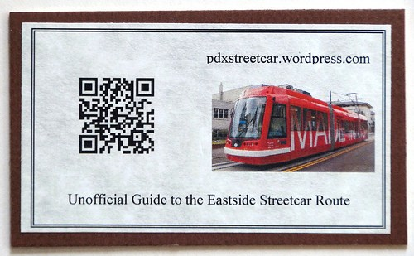
6. Supplemental Documentation:

LINKS AND RESOURCES
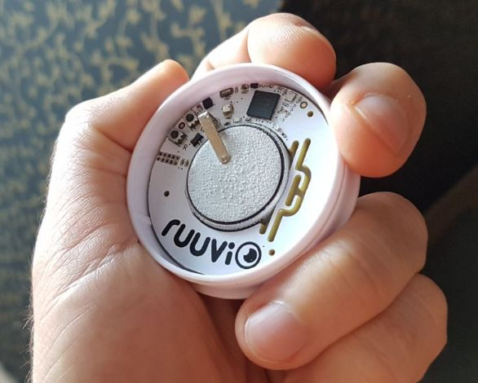
QR Code Virtual Tours
https://pdxstreetcar.wordpress.com
https://kuula.co/post/7fy4S
http://www.gorgevr.org
http://funbeach.org/blog/qr-codes-getting-started
https://www.monuments.com/living-headstones
https://qagis.sanantonio.gov/ohp/hugmantour
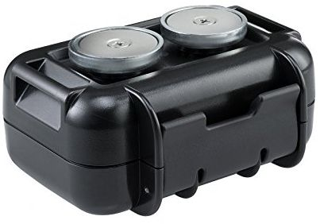
I Heart Campaigns
http://www.iheartyakima.com
https://www.iloveny.com/
QR Code Readers
https://www.qrstuff.com
http://www.3gvision.com/Downloadi-nigmaReader.html

Bluetooth Beacons
https://en.wikipedia.org/wiki/Eddystone_(Google)
https://en.wikipedia.org/wiki/IBeacon
https://developers.google.com/beacons/
Contact:
Sam Churchill (503) 740.9209
12451 North Westshore Dr
Hayden Island
schurchill@gmail.com
Hayden Island Virtual Tour
https://myhaydenisland.wordpress.com/tour/

